



VISVESVARAYA TECHNOLOGICAL UNIVERSITY, JNANASANGAMA, BELAGAVI – 590018

An Internship Project Report on

“DevForge: A Professional Developer Workspace”
Submitted in partial fulfillment for the award of degree of
Bachelor of Engineering In

COMPUTER SCIENCE & ENGINEERING

Submitted by

NANDAN A M 4MO22CS070
Internship Carried Out at
Qspider (A Unit of Test Yantra Software
Solutions India Pvt Ltd), MYSORE
Internal Guide External Guide
Prof. Harshakumar H S Mr. Prajwal C
Assistant Professor Trainer
Department of CSE Qspider

Department of Computer Science & Engineering

MYSORE COLLEGE OF ENGINEERING & MANAGEMENT
(Affiliated to VTU, Belagavi, Approved by AICTE, New Delhi & Govt. of Karnataka)
#072, T Narsipura Road, Near Big Banyan Tree Chikkahalli, Mysore, Karnataka -28

DEPARTMENT OF COMPUTER SCIENCE & ENGINEERING MYSORE COLLEGE OF ENGINEERING AND MANAGEMENT
(Affiliated to VTU, Belagavi, Approved by AICTE, New Delhi & Govt. of Karnataka)
#072, T Narsipura Road, Near Big Banyan Tree Chikkahalli, Mysore, Karnataka -28

2024-2025

CERTIFICATE
This is to certify that the internship project entitled “Qspider (A Unit of Test Yantra Software
Solutions India Pvt Ltd), MYSORE” is a presentation done by Mr. NANDAN A M (4MO22CS070) in partial fulfillment for the award of Bachelor of Engineering in COMPUTER SCIENCE & ENGINEERING of the Visvesvaraya Technological University, Belagavi, during the year 2025 - 2026. The Major project report has been approved as it satisfies the academic requirements in respect of seminar prescribed for the Bachelor of Engineering degree.

…………………………………
Prof. HARSHAKUMAR H S
BE., M.Tech.

Project Guide
Assistant Professor
Department of Computer Science & Engineering MyCEM, Mysore – 570028

………………………………..
Dr. JAYARAM C V
BE., M.Tech., Ph.D.
Project Coordinator Professor
Dept. of CSE MyCEM, Mysore – 570028
……………………………….. Prof. HARSHAKUMAR H S
BE., M.Tech.
HOD
Dept. of CSE MyCEM, Mysore – 570028
………………………………... Dr. MANJUNATHA T S
BE., M.Tech., Ph.D.
PRINCIPAL
MyCEM, Mysore – 570028


Name Signature
- Examiner-1 ……………………………………… ……………………………………

- Examiner-2 .……………………………………… ……………………………………

DECLARATION
I Nandan A M bearing USN: 4MO22CS070 studying in 8th semester in the Dept. of Computer Science and Engineering at Mysore College Of Engineering and Management, Mysore, hereby declare that this project work entitled “DevForge: A Professional Developer Workspace” which is being submitted by us in the partial fulfilment for the award of the degree of Bachelor of Engineering in Computer Science & Engineering, from Visvesvaraya Technological University, Belagavi is an authentic record of us carried out during the academic year 2025- 2026, under the guidance of Harshakumar H S, Assistant Professor, Department of CSE, Mysore College of Engineering and Management, Mysuru.
We further undertake that the matter embodied in the report has not been submitted previously for the award of any degree or diploma by us to any other university or institution.

NANDAN A M (4MO22CS070)

Place: Mysuru Date:

CERTIFICATION
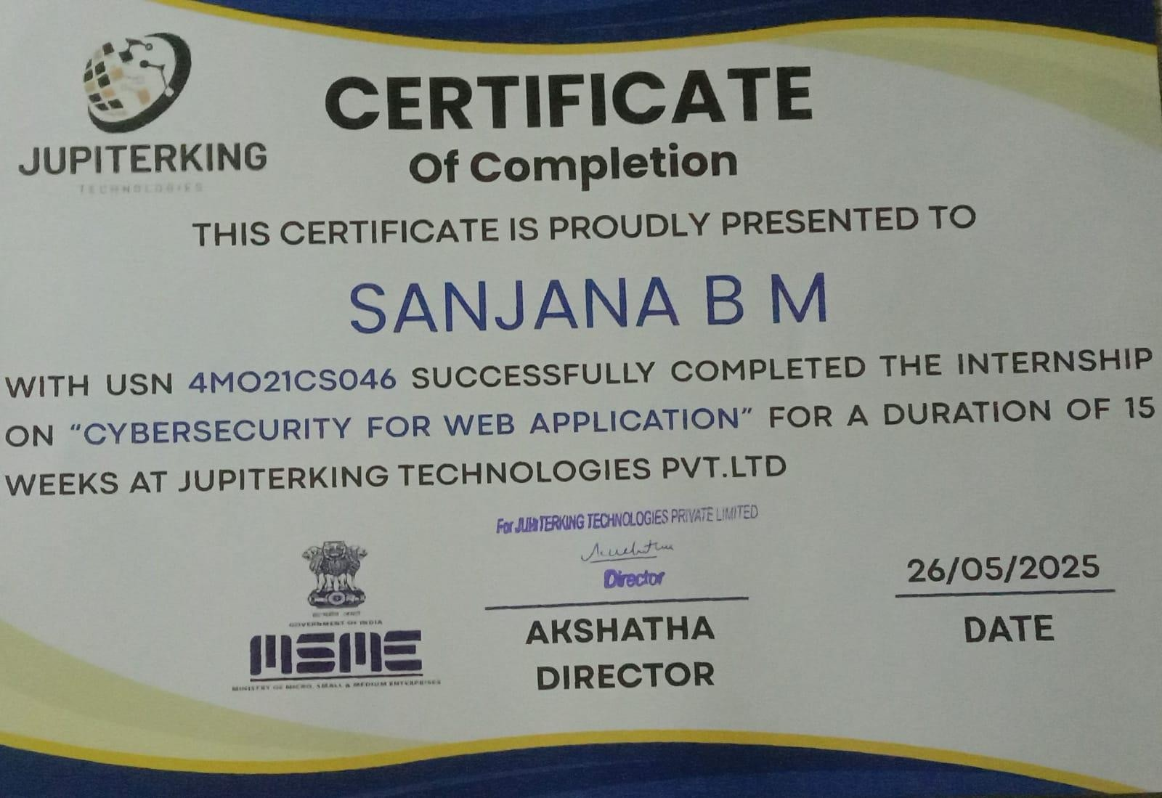

ACKNOWLEDGEMENT
It is my pleasure to be indebted to various people, who directly or indirectly contributed in the development of this work and who influenced my thinking, behavior, and acts during the course of seminar.

I am extremely thankful to our principal Dr. Manjunatha T S for providing us the academic ambience and everlasting motivation to carry out this work and shaping my career.

I express my sincere gratitude to Mr. Harsha Kumar H S, Head of Department, Computer Science & Engineering, MyCEM, for his stimulating guidance, continuous encouragement and motivation throughout the course of internship work.

I wish to enunciate my special thanks to my internship co-ordinator Dr. Jayaram C V, Professor, Department of Computer Science & Engineering, MyCEM, for his constant incitement and advice throughout the internship.

I extend my sincere appreciation to my guide Mr. Harsha Kumar H S, BE., M.Tech, Department of Computer Science & Engineering, MyCEM, who provided his valuable suggestions and precious time in accomplishing my internship.

I am thankful to Mr. Prajwal C, Trainer, Qspider (A Unit of Test Yantra Software
Solutions India Pvt Ltd), MYSORE for their guidance, support, cooperation and motivation during the internship.

I would also like to thank all other teaching and technical staffs of Department of Computer Science and Engineering, who have directly or indirectly helped me in the completion of this internship.

Lastly, I would like to thank the almighty and my parents for their moral support and my friends with whom we shared our day-to-day experience and received lots of suggestions that improved my quality of work.

NANDAN A M
(4MO22CS070)

ABSTRACT

DevForge is a secure and high-performance web application developed to streamline the management of developer assets within a professional workspace. The system allows developers to register themselves, manage technical code snippets, and showcase project portfolios to a community of peers. It is built using modern technologies such as Vanilla CSS for the frontend, Django for the backend, and PostgreSQL as the relational database. The architecture ensures a seamless integration of components through Django’s MVT pattern for efficient communication and data handling.

The primary functionality of the application revolves around allowing developers to submit their "Micro-Assets" such as utility functions, logic snippets, and full-scale projects through a responsive, dark-themed web interface. Once the content is submitted, the system utilizes a Reputation Engine to track developer activity. This feature gamifies the experience by generating activity heatmaps and daily streaks, providing validation for the user’s consistency and technical growth.

To ensure security and privacy, DevForge includes key features such as Google OAuth 2.0 for authentication. This OAuth login allows users to securely log in using their Google accounts, eliminating the need to remember passwords and reducing the risk of credential theft. Additionally, the system employs CSRF tokens and environment variables to protect user data from unauthorized access and session hijacking.

The dashboard serves as the control center, where developers can view their reputation stats, manage their CodeVault snippets, and monitor their BuildBoard project portfolios. All developer data is securely stored in the PostgreSQL database, ensuring reliability and scalability for future enhancements.

In conclusion, DevForge is a comprehensive developer management platform that combines modern web development technologies with essential security protocols. It simplifies the process of asset organization and professional showcasing while maintaining data integrity and user trust. The project showcases an effective use of Python, Django, PostgreSQL, and advanced CSS techniques to create a scalable, secure, and efficient solution tailored for the modern developer ecosystem.
TABLE OF CONTENTS

 |  | Page No
 | ACKNOWLEDGEMENT | i
 | ABSTRACT | ii
 | LIST OF FIGURES | v
 | LIST OF ABBREVIATIONS | vi
CHAPTER 1 | INTRODUCTION | 1
 | 1.1 OVERVIEW | 1
 | 1.2 MOTIVATION BEHIND THE PROJECT | 1
 | 1.3 PROBLEM STATEMENT | 1
 | 1.4 SCOPE | 2
CHAPTER 2 | COMPANY PROFILE | 3
 | 2.1 ABOUT THE ORGANIZATION | 3
 | 2.2 NATURE OF THE WORK | 3
 | 2.3 DEPARTMENT INVOLVED | 4
 | 2.4 TECHNOLOGIES USED | 4
CHAPTER 3 | OBJECTIVES | 5
CHAPTER 4 | MOTIVATION | 7
CHAPTER 5 | METHODOLOGY | 8
 | 5.1 PLANNING AND REQUIREMNT GATHERING | 8
 | 5.2 SYSTEM DESIGN AND ARCHITECTURE | 8
CHAPTER 6 | SYSTEM REQUIREMENTS | 11
 | 6.1 HARDWARE REQUIREMENTS | 11
 | 6.2 SOFTWARE REQUIREMENTS | 11
 | 6.3 SYSTEM PREREQUISITES | 12
 | 6.4 USER ROLES SUPPORTED | 12
CHAPTER 7 | IMPLEMENTATION | 14
 | 7.1 TECNOLOGY STACK USED | 14
 | 7.2 FRONTEND IMPLEMENTATION | 14
 | 7.3 BACKEND IMPLEMENTATION | 15
 | 7.4 DATABASE IMPLEMENTATION | 15
 | 7.5 AUTHENTICATION AND SECURITY FEATURES | 15
 | 7.6 CERTIFICATE GENERATION | 16
 | 7.7 TESTING AND DEBUGGING | 16
 | 7.8 DEPLOYMENT READLINES | 16

CHAPTER 8 | TESTING AND VALIDATION | 17
 | 8.1 POSTMAN API TESTING | 17
 | 8.2.1 POSTMAN TESTING FOR OAUTH LOGIN | 19
 | 8.2 PGADMIN 4 DATABASE TESTING | 20
CHAPTER 9 | SNAPSHOT | 23
 | CONCLUSION | 34
 | FUTURE SCOPE | 35
 | INTERNSHIP OUTCOME | 36
 | REFERENCES | 39

+
LIST OF FIGURES

 | Description | Page No.
Snapshot 9.1 | Login page | 23
Snapshot 9.2 | Intern Should first Signup using required credential | 23
Snapshot 9.3 | OTP is sent by Admin | 24
Snapshot 9.4 | Intern can login through email and password | 24
Snapshot 9.5 | Intern can login using Google account | 25
Snapshot 9.6 | Intern enters an email and password | 25
Snapshot 9.7 | Forgot Password | 26
Snapshot 9.8 | Intern will enter OTP sent by admin | 26
Snapshot 9.9 | Dashboard of Intern-Space | 27
Snapshot 9.9 | College Management | 27
Snapshot9.10 | New College can be added by Admin | 28
Snapshot9.11 | College Added By Admin | 28
Snapshot9.13 | College can be deleted and updated by Admin | 29
Snapshot9.14 | Admin can add Intern | 29
Snapshot9.15 | Intern Management and Intern added by admin will display | 29
Snapshot9.16 | Admin can update or delete the Intern | 30
Snapshot9.17 | Internship Technologies | 30
Snapshot9.18 | New Technology can be added by Admin | 31
Snapshot9.19 | Admin can update or delete Intern Management | 31
Snapshot9.20 | Certificate Management | 32
Snapshot9.21 | Required credentials filled by an Admin and certificate is generated | 32
Snapshot9.22 | Internship Certificate is generated | 33
Snapshot9.23 | Data is stored in backend and we can check that in pgAdmin | 33

LIST OF ABBREVIATIONS

Abbreviation | Full Form
API | Application Programming Interface
BE | Bachelor of Engineering
BCA | Bachelor of Computer Applications
DB | Database
GUI | Graphical User Interface
HTML | HyperText Markup Language
HTTP | Hypertext Transfer Protocol
JWT | JSON Web Token
MCA | Master of Computer Applications
OTP | One-Time Password
PDF | Portable Document Format
pgAdmin | PostgreSQL Graphical Administration Tool
REST | Representational State Transfer
SQL | Structured Query Language
UI | User Interface
VS Code | Visual Studio Code
XSS | Cross-Site Scripting
CSRF | Cross-Site Request Forgery
OAuth | Open Authorization
CLI | Command Line Interface
ORM | Object-Relational Mapping
JPA | Java Persistence API
IDE | Integrated Development Environment

CHAPTER 1

Overview

INTRODUCTION

JupiterKing Intern Space is a full-stack internship management system designed to digitize and automate the end-to-end process of managing internship programs within organizations, especially those in collaboration with academic institutions. Developed using React for the frontend and Spring Boot for the backend, the application is structured on a RESTful API architecture, ensuring smooth and secure communication between the frontend and backend components. The data is stored in PostgreSQL, managed via pgAdmin, enabling efficient and scalable database operations.
The system offers key modules including Dashboard, College Management, Intern Management, Internship Technologies, and Certificate Management, providing a unified platform for admin and intern users. It also integrates modern cybersecurity features such as OTP-based login and OAuth-based login (using Google or Microsoft accounts), enhancing user authentication and data protection. The primary function is to allow interns to register, get approved by an admin, and receive an officially validated digital internship certificate.

Motivation Behind the Project
In today’s digital era, managing internships manually is inefficient, time-consuming, and prone to errors. Many companies and institutions still rely on paper-based processes or unstructured digital records to track intern details and issue certificates. This leads to mismanagement, delays, and a lack of transparency. Moreover, interns often face difficulty in getting their internship certificates verified in a standardized way.
The motivation behind JupiterKing Intern Space is to develop a secure, centralized platform that not only automates the process but also ensures legitimacy through proper admin validation and digital certification. The inclusion of cybersecurity measures further enhances the trustworthiness and usability of the system for real-world application.

Problem Statement
Most organizations and educational institutions lack a robust, digital platform to manage

internships. The absence of a centralized system results in:
    - Inconsistent tracking of intern data and participation.
    - Delayed issuance and verification of internship certificates.
    - Limited integration between companies and colleges.
    - Security concerns related to intern data and user login.
    - Manual work for administrators in handling multiple intern records.
There is a clear need for a comprehensive, secure, and automated internship management solution that bridges the gap between interns, colleges, and companies.

Scope
The scope of the JupiterKing Intern Space project includes:
    - Development of a responsive frontend using React.
    - Backend API development using Spring Boot with secure and scalable architecture.
    - Integration with PostgreSQL for reliable data storage, managed via pgAdmin.
    - Implementation of essential modules:
      - Dashboard for overview and analytics.
      - College Management to track associated institutions.
      - Intern Management for handling intern records.
      - Internship Technologies to assign technical domains.
      - Certificate Management for auto-generating internship certificates.
    - Integration of OTP-based login for secure verification.
    - Implementation of OAuth-based login via Google/Microsoft for seamless access.
    - Suitable for use by companies, colleges, and individual interns across domains.

CHAPTER 2

COMPANY PROFILE

About the organization


JupiterKing Technologies is a software development and training company based in Mysuru, Karnataka, India. Established on April 23, 2024, the company operates as a private limited entity with an authorized capital of ₹1 million and a paid-up capital of ₹20,000.JupiterKing Technologies specializes in software development and offers training services in trending software technologies, aiming to facilitate placements for its trainees. The company is led by CEO and Director Akshatha K C.
JupiterKing Technologies, based in Mysuru, Karnataka, focuses on providing comprehensive IT services, including job-oriented technology training, internships for BE/Diploma/BCA/MCA students, and project guidance. Their mission is to empower students with industry-relevant skills, ensuring they become job-ready professionals. Additionally, they specialize in software development and offer training in trending software technologies, aiming to facilitate placements for their trainees.

Nature of the work

JupiterKing Technologies, based in Mysuru, Karnataka, specializes in software development and offers training services in trending software technologies, aiming to facilitate placements for its trainees. Additionally, they provide job-oriented Technology training, internships for

BE/Diploma/BCA/MCA students, and project guidance, focusing on empowering students with industry-relevant skills to ensure they become job-ready professionals.

Department involved
JupiterKing Technologies in Mysuru operates through several key departments to deliver its services:
Software Development Department: Focuses on creating customized software solutions tailored to client needs.
Training and Education Department: Provides job-oriented technology training, internships, and project guidance to students pursuing BE, Diploma, BCA, and MCA degrees. Placement and Career Services Department: Assists trainees in securing job placements by offering career counseling, resume building, and interview preparation support.
These departments collaborate to ensure the delivery of comprehensive IT services, aligning with the company's mission to empower students with industry-relevant skills and facilitate their transition into the professional world.

Technologies used by the organization
JupiterKing Technologies, based in Mysuru, Karnataka, offers a variety of IT services, including job-oriented technology training and internships for BE/Diploma/BCA/MCA students. Their training programs cover a range of technologies, such as:
- Full-stack Web application development
- Full-stack test automation using Selenium
- Cybersecurity for applications
- Data Analytics and Machine Learning

CHAPTER 3

OBJECTIVES

The JupiterKing Intern Space project aims to build a full-fledged, secure, and efficient internship management platform that connects interns, colleges, and companies through a single digital ecosystem. Developed using modern web technologies—React for frontend, Spring Boot for backend APIs, and PostgreSQL (managed through pgAdmin) for the database—the system is designed to simplify and automate every aspect of internship handling. The project also emphasizes strong cybersecurity by incorporating OTP-based login and OAuth-based login mechanisms, ensuring both user convenience and data protection.

Below are the expanded objectives of this project:
- To Build a Responsive Web Application Using React
Design and develop a dynamic, user-friendly interface that allows users (interns and admins) to access the platform on multiple devices.
Use component-based architecture in React to ensure scalability and maintainability.
- To Implement a Secure and Scalable Backend Using Spring Boot
Create RESTful APIs to handle core business logic, user actions, data validation, and interactions with the database.
Ensure proper API layering for handling requests related to registration, login, certificate generation, and admin operations.
- To Centralize and Visualize Data Using the Dashboard Module
Develop a dashboard that provides key metrics: total interns, colleges, departments, certificates issued, and technologies used.
Display recent activities, pending approvals, and technology preferences for better decision- making.
- To Simplify Academic Collaborations via College Management Module
Enable admins to add, update, and manage multiple colleges and their respective departments. Associate interns with their institutions for better reporting and certificate verification.
- To Manage Intern Records through the Intern Management Module
Allow interns to register themselves by filling in personal, academic, and technical details. Provide admins with capabilities to approve/reject intern applications, assign technologies, and

track progress.
- To Organize Internship Domains via the Internship Technologies Module
Maintain a structured list of available technologies (e.g., Java, Angular, Python, Data Science). Assign technologies to interns based on preferences or institutional requirements.
- To Automate Certificate Creation in the Certificate Management Module
Generate customized internship completion certificates with intern name, technology, duration, and company branding.
Provide secure access to download certificates or send them via email for future reference and validation.
- To Strengthen User Authentication with Modern Cybersecurity Measures
Use OTP-based login to verify user identity at the time of registration or login, adding an extra layer of protection.
Integrate OAuth-based login using trusted third-party providers like Google and Microsoft to enhance user convenience and eliminate password-related vulnerabilities.
- To Ensure Reliable Data Storage Using PostgreSQL and pgAdmin
Use PostgreSQL for managing relational data efficiently, with pgAdmin as a GUI to monitor and maintain data integrity.
Design normalized schemas to store intern details, college data, login credentials, certificates, and activity logs.

By fulfilling these objectives, JupiterKing Intern Space will serve as a modern, secure, and intelligent system for internship management—streamlining processes, minimizing manual effort, and improving organizational productivity across institutions and industries.

CHAPTER 4

MOTIVATION
In the modern educational and corporate ecosystem, internships play a crucial role in bridging the gap between academic knowledge and practical industry experience. However, most organizations and academic institutions still rely on outdated or semi-automated methods to manage intern records, verify participation, and issue certificates. These manual systems are often inefficient, error-prone, and difficult to scale, especially when dealing with large volumes of students from multiple colleges. The lack of a unified platform also creates communication gaps between interns, administrators, and educational institutions.
The JupiterKing Intern Space project is motivated by the need to create a centralized, digital, and secure internship management system that simplifies and automates the entire process. Built using modern technologies such as React for the frontend, Spring Boot for the backend, and PostgreSQL (managed through pgAdmin) for the database, the system ensures performance, reliability, and scalability. It is designed to eliminate repetitive tasks like manual intern data entry, email-based communication, and manual certificate creation, by offering an integrated platform with intuitive modules.
Another core motivation behind this project is the growing importance of cybersecurity. As data privacy and security concerns become increasingly important, especially in systems that deal with personal and institutional information, the project includes robust authentication features like OTP-based login to validate users during access attempts, and OAuth-based login via Google or Microsoft accounts to enable secure, third-party-verified login mechanisms.
The development of specific modules such as Dashboard, College Management, Intern Management, Internship Technologies, and Certificate Management further reinforces the vision of creating an all-in-one platform. These modules allow seamless intern registration, technology tracking, real-time analytics, and automated certificate generation, all under a single system.
Ultimately, the motivation behind JupiterKing Intern Space is to empower organizations and educational institutions with a smart, efficient, and secure solution to manage internships. It aims to reduce administrative overhead, improve user experience, and ensure that every intern receives the recognition they deserve—without delays or manual intervention. The system also fosters collaboration between companies and colleges, offering transparency and real-time data tracking across all users involved.

CHAPTER 5

METHODOLOGY
The JupiterKing Intern Space project was developed using a structured and modular approach, integrating both front-end and back-end technologies to create a seamless and secure internship management system. The methodology involved multiple stages including planning, analysis, design, development, integration, testing, and deployment. The project adopts Agile principles, allowing for iterative development and regular feedback.

Planning & Requirement Gathering
The first step was to identify the key requirements from an intern's and admin’s perspective. A thorough analysis was conducted to understand the lifecycle of an internship—from registration to certificate generation. Functional needs (e.g., intern registration, college mapping, tech assignment) and non-functional needs (e.g., security, scalability, user experience) were documented.
Tools Used:
    - Google Docs for requirement specifications
    - Draw.io for early module sketching
    - Trello for sprint planning and task tracking

5.2. System Design & Architecture
The system was designed as a three-tier architecture:
- Frontend (React.js) – Responsible for user interface, form validations, and API communication.
- Backend (Spring Boot) – Contains business logic, REST APIs, and handles authentication/authorization.
- Database (PostgreSQL via pgAdmin) – Manages persistent storage for users, colleges, internships, and certificates.
Key design elements include:
- Component-based UI for reusability
- RESTful API design for clear separation of concerns
- Entity-Relationship diagrams to model data structure

Security Consideration in Design:
- Encrypted data transmission via HTTPS
- Stateless session handling with JWT for OAuth
- OTP generation and expiry logic using Spring Security

- Frontend Development (React.js)
- Built interactive and responsive components using React Hooks and functional components.
- Axios used to connect securely with backend APIs.
- React Router for navigation between dashboard, forms, and reports.
- Input validation and form error handling implemented using Formik and Yup libraries. Frontend Highlights:
- Dynamic dashboards showing intern counts and progress
- User-friendly forms for intern registration and technology assignment
- Admin panels for colleges and certificate management

- Backend Development (Spring Boot)
- REST APIs developed following clean coding practices and layered architecture (Controller, Service, Repository).
- Spring Security integrated for user login with role-based access (Admin vs Intern).
- OTP-based login system built with token generation, storage, and verification flow.
- OAuth 2.0 login enabled using Google Identity Provider with secure redirect handling. Backend Modules:
- User Module – Intern/admin registration, login with OTP/OAuth
- College Module – CRUD operations for college and department management
- Intern Module – Intern tracking and tech assignment
- Certificate Module – On-demand PDF certificate generation
- Audit Logs – Maintains logs for security and monitoring

- Database Management (PostgreSQL with pgAdmin)
- PostgreSQL chosen for its robust relational capabilities and scalability.
- Tables normalized to reduce redundancy (User, Intern, College, Technology, Certificate).

- pgAdmin used for schema design, SQL query execution, and performance tuning. Special Features:
- Foreign key constraints for secure data relationships
- Indexing on frequently queried fields (like intern email, college ID)

- Security Implementation
- OTP-based Authentication: Random OTP generated, sent to user’s email/phone, stored with expiry logic, validated before login.
- OAuth-based Authentication: Google OAuth API integrated to allow seamless and secure third-party login.
- JWT tokens issued after successful login for session management.
- Passwords stored using hashing algorithms (BCrypt).
- Backend protected from common threats: SQL Injection, Cross-Site Scripting (XSS), CSRF, etc.

- Testing & Quality Assurance
- Unit tests written using JUnit for backend services.
- Manual and automated testing performed for frontend validation.
- Cross-browser compatibility checks on Chrome, Firefox, and Edge.
- Functional testing done for login flows, form submissions, and certificate downloads.

- Deployment & Future Enhancements
- Deployed in a local server environment using Spring Boot’s embedded Tomcat and PostgreSQL.
- System designed to be cloud-deployable on AWS, Azure, or Heroku.
- Future plans include:
  - Role-based dashboards (e.g., College Coordinator View)
  - Email/SMS OTP delivery system
  - AI-generated insights on intern performance

The JupiterKing Intern Space methodology ensures the solution is not only functional but also secure, modular, and ready for real-world use in managing internships at scale.

CHAPTER 6

SYSTEM REQUIREMENTS
The JupiterKing Intern Space is a full-stack internship management platform built using modern web technologies such as React, Spring Boot, and PostgreSQL. To ensure smooth development, deployment, and operation of the platform, both hardware and software requirements are specified. These requirements ensure the platform performs efficiently across all modules including Dashboard, College Management, Intern Management, Internship Technologies, and Certificate Management, along with integrated cybersecurity features like OTP-based login and OAuth-based login.

Hardware Requirements

For Development Environment (Local Setup)

Component | Minimum Requirement | Recommended Requirement
Processor | Intel i5 (4th Gen) / AMD Ryzen 3 | Intel i7 or AMD Ryzen 5 and above
RAM | 8 GB | 16 GB or more
Storage | 256 GB SSD or 500 GB HDD | 512 GB SSD

    - For Server Deployment
      - Cloud-hosted server (e.g., AWS EC2, Heroku, or DigitalOcean)
      - Minimum:
        - 2 vCPUs
        - 4 GB RAM
        - 50 GB SSD
        - Ubuntu 20.04 LTS or CentOS 7

Software Requirements
- Frontend (Client Side)
  - React.js (v17 or later)
  - Node.js (v16.x or later)

  - NPM/Yarn – For dependency management
  - VS Code / WebStorm – For development
  - Browser – Chrome, Firefox, or Edge (latest versions)
- Backend (Server Side)
  - Java JDK (version 17 or later)
  - Spring Boot (version 3.x)
  - Apache Maven – For project build
  - Postman – For API testing
  - IntelliJ IDEA / Eclipse – For backend development
- Database
  - PostgreSQL (v13 or later)
  - pgAdmin 4 – For GUI-based database administration
- Security Tools
  - Spring Security – For implementing OTP and OAuth login
  - JWT – For secure session handling
  - Google Developer Console – For OAuth 2.0 configuration
- Others
  - Git/GitHub – Version control and collaboration
  - Docker (Optional) – For containerization and microservice deployment
  - Swagger UI – For documenting and testing backend APIs

System Prerequisites
- React build and API should be hosted on the same domain or configured with CORS settings.
- Email/SMS OTP service requires a configured mail server or third-party SMS API (e.g., Twilio, SendGrid).
- OAuth-based login requires registration on Google Cloud Console and appropriate API credentials.
- SSL certificate is recommended for production deployment to ensure secure HTTPS communication.

User Roles Supported

- Admin: Can manage colleges, interns, certificates, and internship technologies.
- Intern: Can register, view assigned technologies, and download certificates.

This system is designed to be lightweight yet scalable, ensuring that it can be deployed in small startups, educational institutions, or scaled to larger enterprise environments with cloud support.

CHAPTER 7

IMPLEMENTATION
The JupiterKing Intern Space project has been implemented as a full-stack web application to streamline internship management for educational institutions and organizations. The implementation focuses on modular development, robust backend logic, a responsive frontend interface, and secure authentication mechanisms.

Technology Stack Used
    - Frontend: ReactJS (with Axios, React Router, and Material-UI/Tailwind for styling)
    - Backend: Spring Boot (Java 17), Spring Security, Spring Data JPA
    - Database: PostgreSQL with pgAdmin for GUI management
    - Security: OTP-based login (custom email system), OAuth 2.0 using Google authentication, JWT-based session management
    - Tools: GitHub (version control), Postman (API testing), Swagger (API documentation)

Frontend Implementation (ReactJS)
Key Features:
    - Routing: Implemented using React Router with protected routes based on user roles (admin, intern).
    - State Management: Utilized React’s context API or useState/useEffect for lightweight state management.
    - Responsive UI: Built using Material-UI or Tailwind CSS for a mobile-friendly interface.
    - API Integration: Axios is used to communicate with backend endpoints securely with JWT in headers.
Modules:
- Dashboard: Real-time charts and stats on colleges, interns, and certificates.
- College Management: Add/edit/delete colleges and departments.
- Intern Management: Intern registration form, list view, and edit capability.
- Internship Technologies: Dropdown-driven management and assignment of technology stacks.
- Certificate Management: Display and PDF download of certificates using dynamic

data.

Backend Implementation (Spring Boot)
Core Components:
    - REST API: Developed using Spring MVC with controller-service-repository structure.
    - Database Operations: Performed using Spring Data JPA and Hibernate for ORM mapping.
    - Security Logic: Implemented with Spring Security and JWT.
Major Endpoints:
    - POST /auth/otp: Generate and send OTP
    - POST /auth/verify: Verify OTP and issue JWT
    - GET /auth/oauth: Redirect to Google OAuth and fetch user info
    - GET /colleges: Retrieve college list
    - POST /interns: Register a new intern
    - GET /certificates/:id: Download certificate
Business Logic:
    - Validation checks on data entry (e.g., no duplicate interns, valid email formats).
    - Role-based authorization for secure resource access.
    - Automatic certificate generation logic using Java libraries.

Database Implementation (PostgreSQL + pgAdmin)
Key Tables:
    - users: Stores login data and roles (admin/intern)
    - colleges: Contains college name, department, etc.
    - interns: Holds intern details linked to college and technology
    - technologies: List of internship domains
    - certificates: Stores certificate records (issue date, intern ID)
    - otp_tokens: Temporary OTP storage with expiry logic
Design Notes:
    - Foreign key constraints between colleges and interns
    - Indexes for performance optimization
    - Data integrity through transactions and cascading rules

Authentication & Security Features

OTP Login:
    - OTP generated and sent to email via Spring Mail or third-party services (e.g., SendGrid).
    - OTPs stored with timestamps in the otp_tokens table.
    - After verification, JWT is issued for session management.
OAuth 2.0 Login:
    - Integrated with Google using client ID and secret via Spring Security OAuth2.
    - Redirect and callback flow handled securely with token verification.
    - Allows seamless and passwordless login.
JWT-Based Security:
    - JWT tokens stored in local storage on the frontend.
    - Every protected API checks for a valid token before processing.

Certificate Generation
    - Certificate templates designed as PDFs using iText or JasperReports.
    - Auto-filled with intern details and internship duration.
    - Interns can download their certificate upon successful completion.

Testing & Debugging
    - APIs tested thoroughly using Postman.
    - React components tested manually and through console logs.
    - Form validation and user flow tested with real-time data from the backend.
    - Security tested with token expiration, invalid OTPs, and unauthorized access attempts.

Deployment Readiness
    - Frontend build (React) prepared using npm run build and served on cloud (e.g., Netlify, Vercel, or Nginx).
    - Backend hosted on a server (e.g., AWS, Render) with PostgreSQL database configured.
    - SSL certificate configured for secure HTTPS-based communication.

This modular and secure implementation ensures the system is reliable, user-friendly, and ready to be used by colleges and students for effective internship and certificate management.

CHAPTER 8

TESTING AND VALIDATION

Postman API Testing – JupiterKing Intern Space
Postman was extensively used during the development and testing phases of the JupiterKing Intern Space project to ensure that each REST API endpoint exposed by the Spring Boot backend was functioning as intended. It helped validate request-response structures, test security features, and simulate frontend interactions during development.

Purpose of Postman API Testing
      - Verify the correct functionality of each REST endpoint.
      - Ensure data consistency between frontend (React) and backend.
      - Check authentication & authorization using JWT tokens.
      - Simulate OTP and OAuth login flows.
      - Test error handling (invalid data, unauthorized access).
      - Automate test cases using Postman Collections.

    - Sample API Test Scenarios in Postman
      - Authentication APIs
- Generate OTP
  - Endpoint: POST /api/auth/send-otp
  - Request Body:
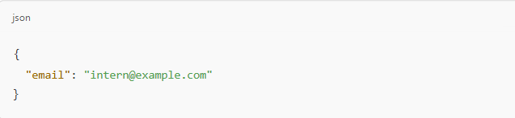
  - Expected Result: OTP sent successfully to registered email and stored in DB.
- Verify OTP and Generate Token
  - Endpoint: POST /api/auth/verify-otp
  - Request Body:

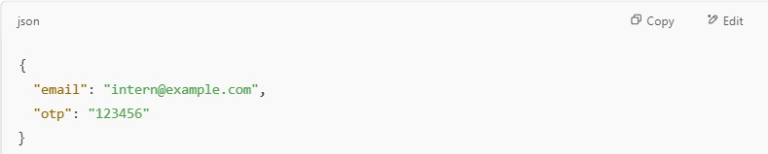
Expected Result: Valid OTP returns a JWT token for secure session.

      - College Management
- Get All Colleges
Endpoint: GET /api/colleges
Headers: Authorization: Bearer <JWT_TOKEN> Expected Result: List of all registered colleges.
- Add College
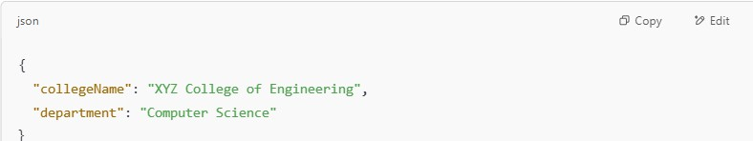
Endpoint: POST /api/colleges Request Body:
  - Expected Result: New college added to database.
      - Intern Management
- Register New Intern
  - Endpoint: POST /api/interns
  - Request Body:
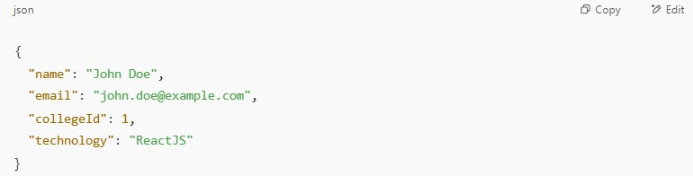
  - Expected Result: Intern record created and linked to college.
- Get Interns List

  - Endpoint: GET /api/interns
  - Headers: Authorization: Bearer <JWT_TOKEN>
  - Expected Result: Returns a list of all registered interns.
      - Internship Technologies
1. Add New Technology
- Endpoint: POST /api/technologies
- Request Body:
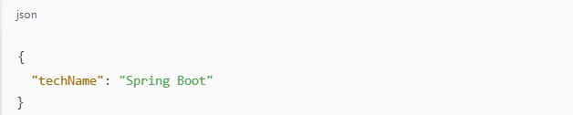

- Expected Result: Technology added for use in intern assignment.

      - Certificate Management
- Generate/Download Certificate
  - Endpoint: GET /api/certificates/download/{internId}
  - Headers: Authorization: Bearer <JWT_TOKEN>
  - Expected Result: PDF certificate downloaded with intern’s data.

Postman Testing for OAuth Login
Since OAuth flows involve browser-based redirection, direct testing is limited. But token validation can be tested:
      - OAuth Token Received → Token sent via Postman in Authorization header.
      - Test Access-Controlled Endpoints using OAuth token to simulate access.

Postman Collection Usage
        - All endpoints grouped into collections (e.g., Auth, College, Intern, Certificate).
        - Added environment variables for:
          - Base URL (e.g., http://localhost:8080)
          - Token ({{token}})
        - Tests were automated using Postman’s Tests tab with JavaScript snippets, e.g.:

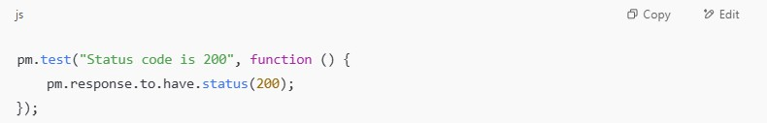

Sample Test Flow
- Call /send-otp → receive OTP (mock or check DB).
- Call /verify-otp → get JWT.
- Set JWT in Postman Environment.
- Call secured endpoints (/interns, /certificates, etc.).
- Verify status, response body, and database updates.

Benefits of Using Postman in JupiterKing
  - Reduced manual frontend testing by validating backend logic early.
  - Allowed mocking authentication before frontend OAuth was ready.
  - Made it easy to troubleshoot errors and inspect full HTTP responses.
  - Helped verify data structure and API documentation.

pgAdmin 4 Database Testing
pgAdmin 4 is a powerful, open-source PostgreSQL management tool that provides a user- friendly interface for database development, testing, and administration. In the JupiterKing Intern Space project, pgAdmin 4 was used extensively to test and validate the backend database operations handled by Spring Boot APIs. The project relies on PostgreSQL as the primary data storage system, making pgAdmin 4 an essential tool for maintaining data integrity across all modules.

Purpose of Database Testing
The purpose of database testing using pgAdmin 4 was to ensure that all data transactions initiated from the frontend (React) and handled by the backend (Spring Boot) were correctly stored, updated, and retrieved. It also helped validate:
      - The relational consistency among various entities.

      - Data accuracy in complex joins (e.g., intern-college-technology relationships).
      - The enforcement of constraints (unique, foreign keys, not null).
      - Correct storage and expiration of authentication credentials (OTP/OAuth tokens).

Modules and Related Tables Tested
The database schema was designed to support the following core modules. Each module was tested through queries and manual data inspections in pgAdmin 4.
- College Management
  - Table: college
  - Fields: college_id, college_name, department, created_at
  - Testing Focus:
    - Validation of unique college names.
    - Proper linkage with interns.
    - Query filters by department.
- Intern Management
  - Table: intern
  - Fields: intern_id, name, email, college_id, technology, registration_date
  - Testing Focus:
    - One-to-many relationship with colleges.
    - Email uniqueness and format validation.
    - Retrieval of all interns under a specific college.
- Internship Technologies
  - Table: technology
  - Fields: tech_id, tech_name
  - Testing Focus:
    - Dynamic insertion and mapping with interns.
    - Duplicate prevention for technologies.
- Certificate Management
  - Table: certificate
  - Fields: certificate_id, intern_id, issue_date, certificate_path
  - Testing Focus:
    - One-to-one mapping with intern.
    - Certificate download link validation.

    - Re-issuance testing by tracking multiple entries.
- Authentication & Security
  - Table: otp_login, oauth_sessions
  - Fields: otp_id, email, otp_code, created_at, status session_id, user_id, provider, token, issued_at, expires_at
  - Testing Focus:
    - OTP expiration and validation rules.
    - Session tracking with token storage.
    - Ensuring tokens are hashed and not exposed.

Data Integrity & Security Testing
      - OTP Testing:
        - Validated the OTP expiration by comparing created_at with current time.
        - Confirmed OTP is invalid after usage or timeout.
      - OAuth Token Validation:
        - Verified token issuance timestamps and expiry logic.
        - Cross-checked session logs for abnormal or unauthorized access attempts.
      - Referential Integrity:
        - Ensured foreign key constraints between intern and college tables.
        - Prevented orphan records using ON DELETE CASCADE for related data.

Tools and Features Used in pgAdmin 4
      - Query Tool: To run manual SQL queries and verify CRUD operations.
      - ERD Tool (Database Designer): To visualize relationships between tables.
      - Data View Grid: To observe real-time data updates after API calls.
      - Import/Export Feature: For testing bulk data import and exporting certificates/logs.

Database testing using pgAdmin 4 ensured the reliability and robustness of the backend storage layer of the JupiterKing Intern Space project. It helped validate each operation performed via the REST API endpoints, ensured tight data security for sensitive information like OTPs and tokens, and reinforced proper functioning of the core modules: college management, intern tracking, technology mapping, and certificate generation.

CHAPTER 9

SNAPSHOT
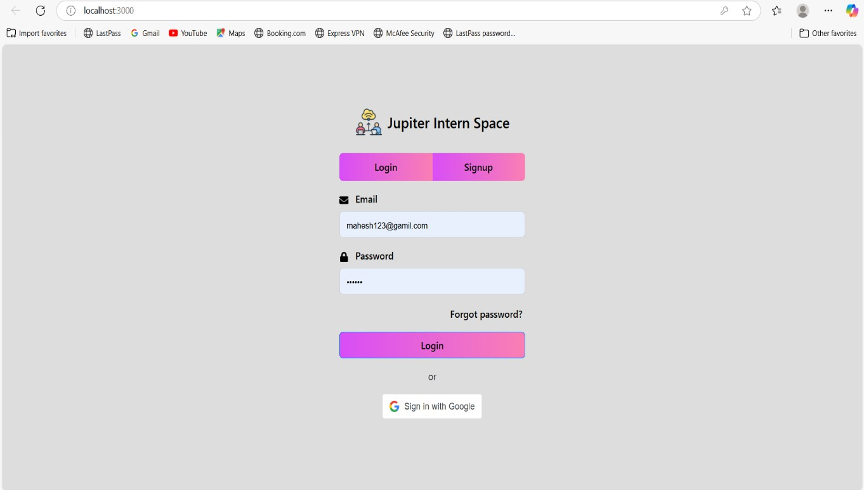
Fig 9.1 : Login page of Jupiter Intern-Space

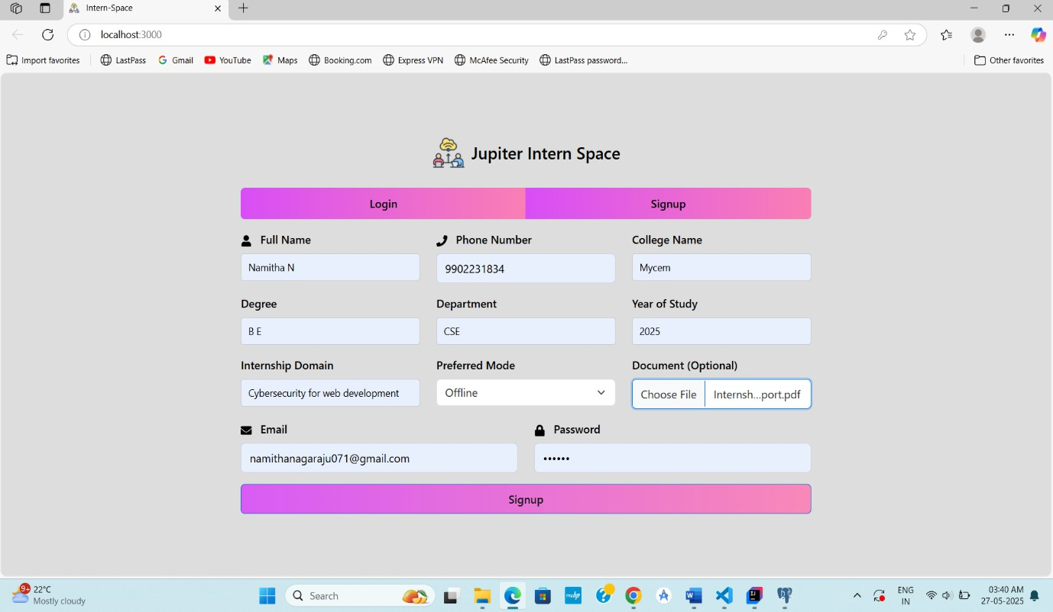
Fig 9.2 : Intern Should first Signup Using required credentials

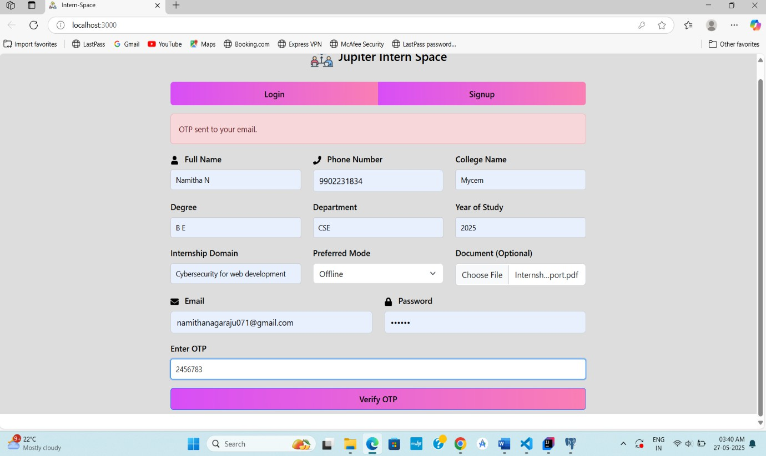
Fig 9.3 :After Signup by an intern and OTP is sent by an Admin for verification purpose

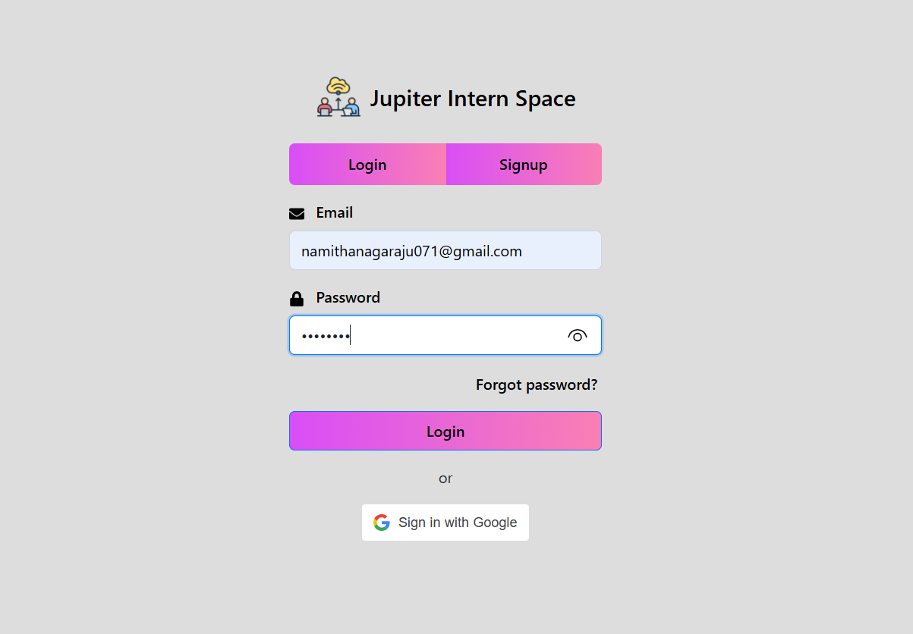
Fig 9.4 :After login Intern can Login in to website using Email and password

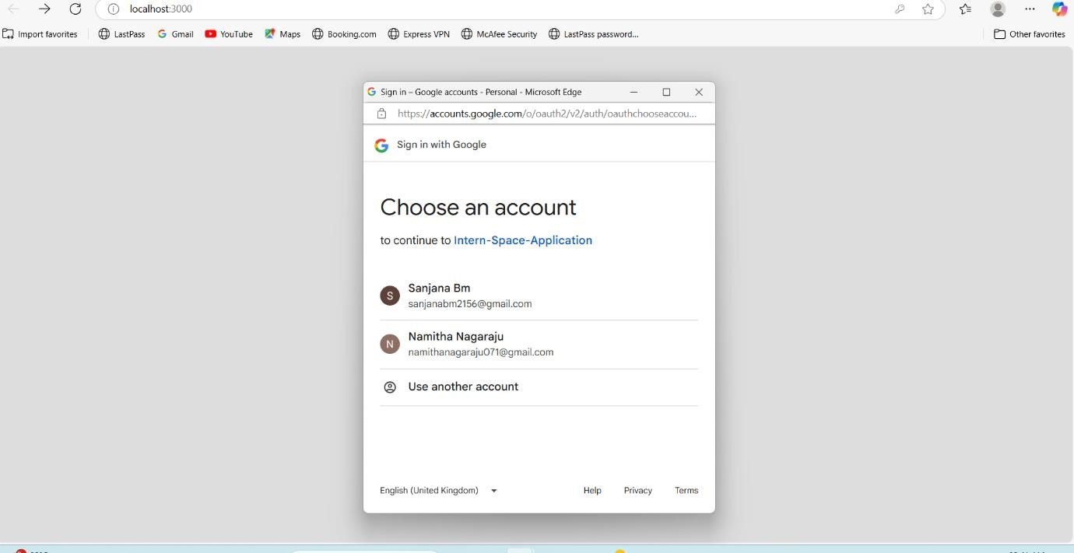
Fig 9.5 : Intern can login using google account also

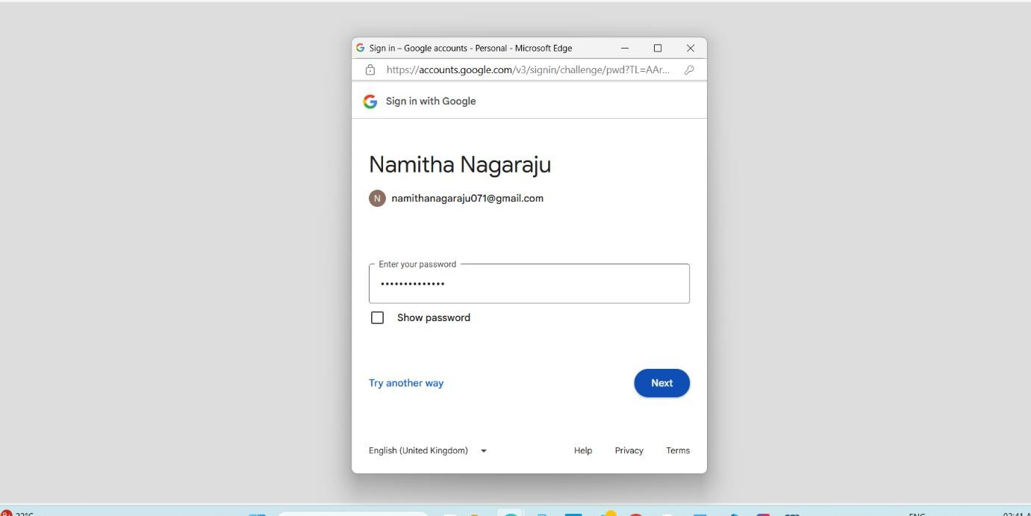
Fig 9.6 : Login Should enter a email id and password

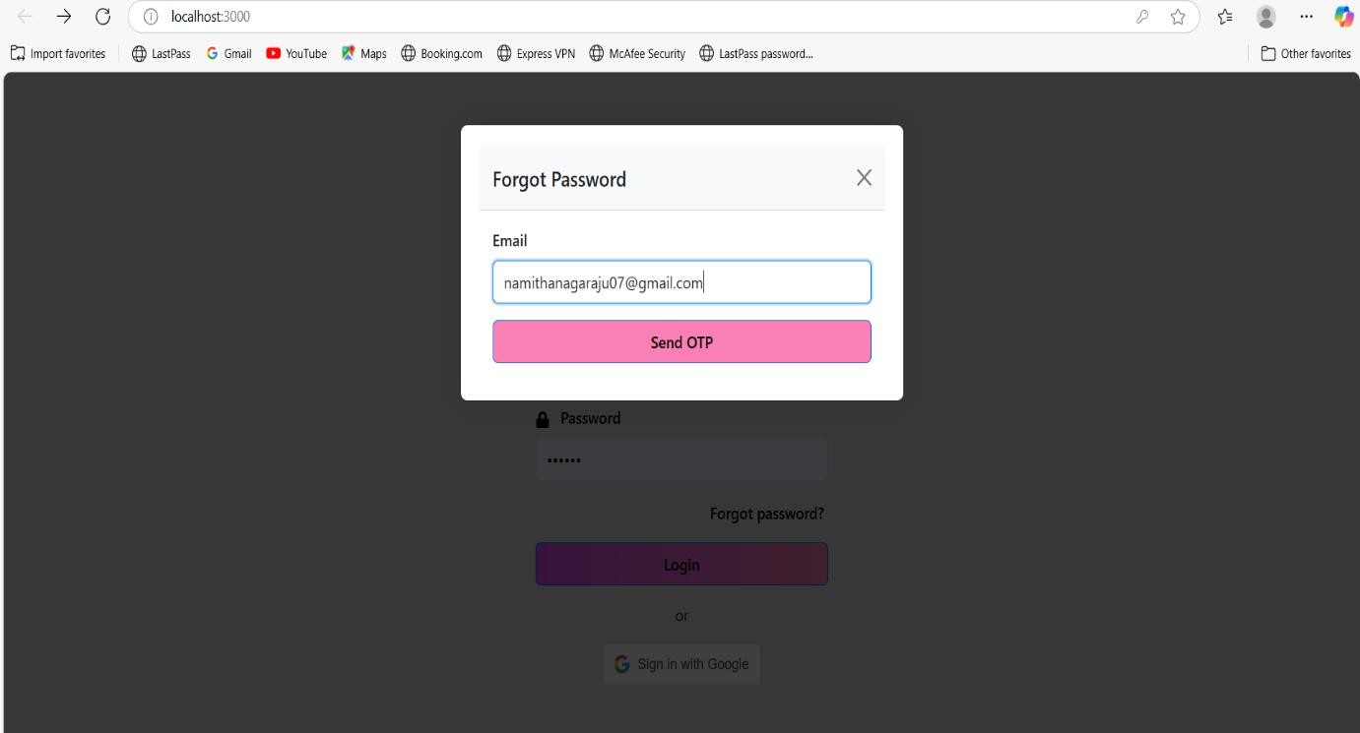

Fig 9.7: If Intern Forgot the password if he/she enter the Email and request to send OTP Admin Will send OTP to he/she Email id
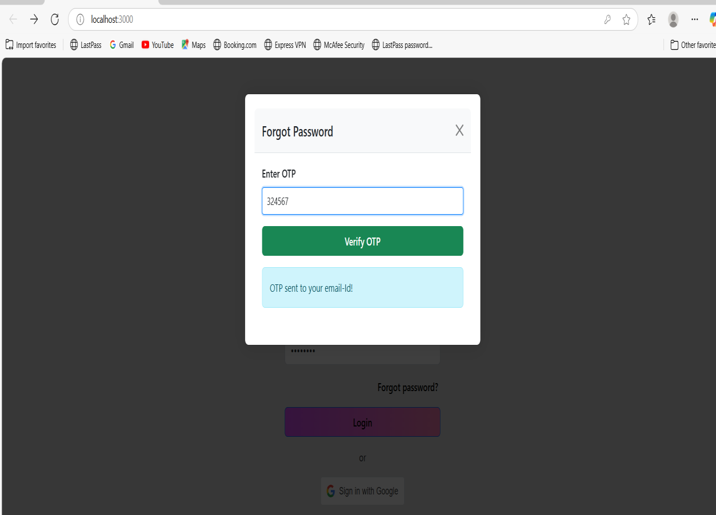

Fig 9.8 : Intern will enter OTP sent by Admin and Login into Home Page

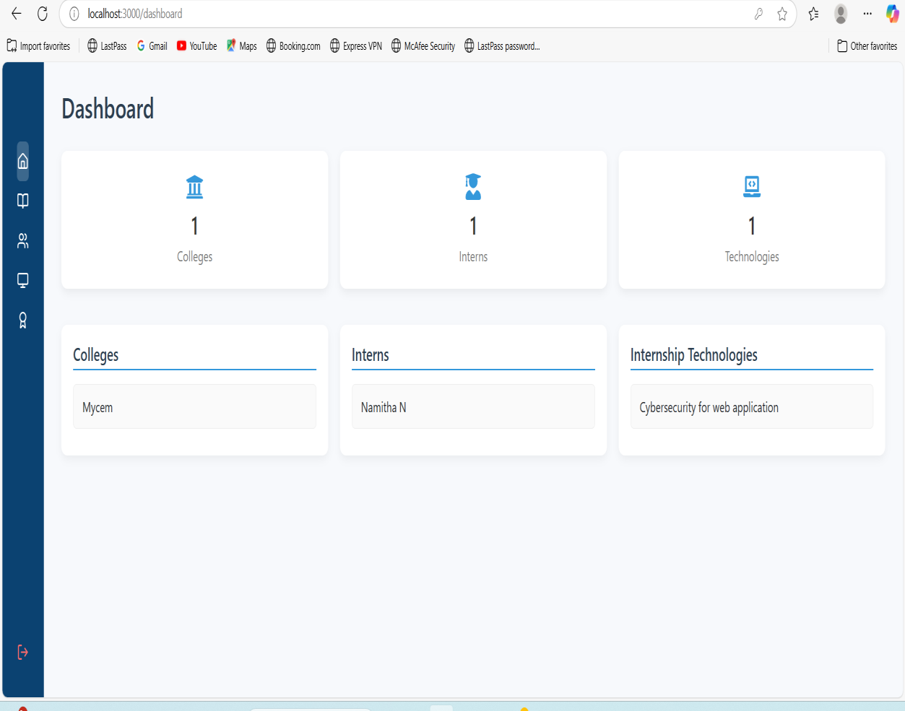
Fig 9.9 Dashboard of Intern-Space

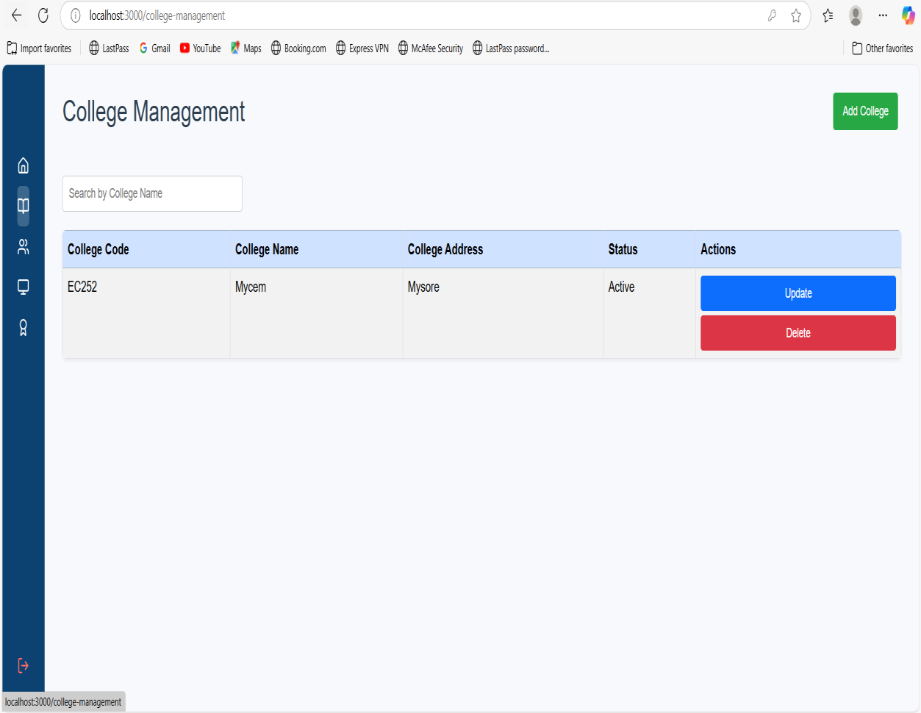
Fig 9.10 : College Management

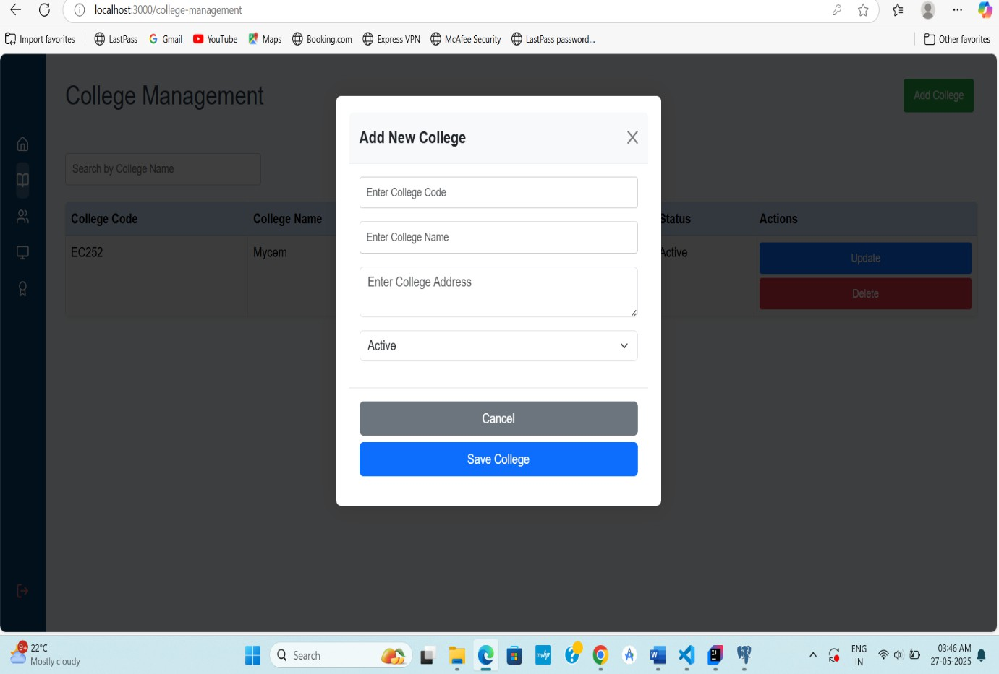
Fig 9.11: New College can be add by Admin



Fig 9.12 : College Added By Admin

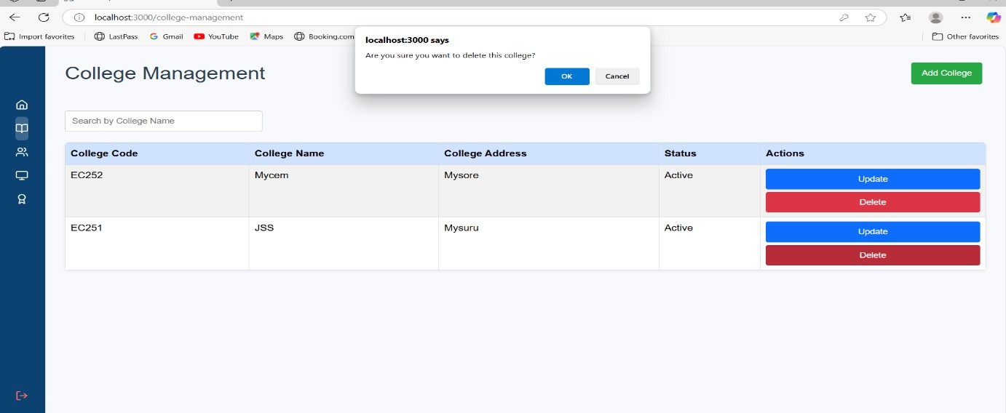
Fig 9.13 : College can be deleted and Updated By Admin
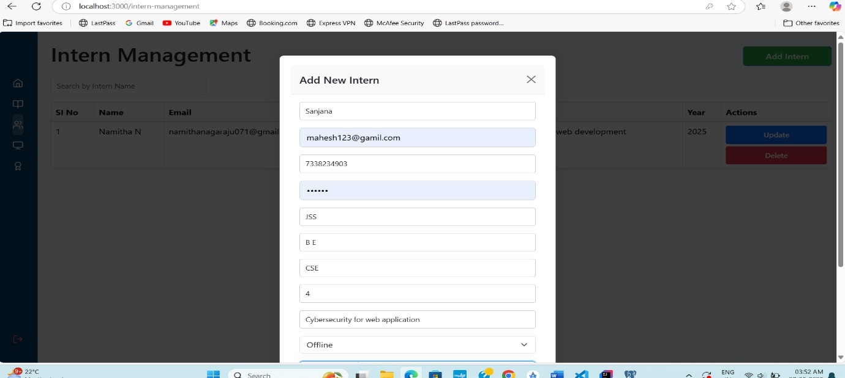
Fig 9.14 : Admin can add Intern
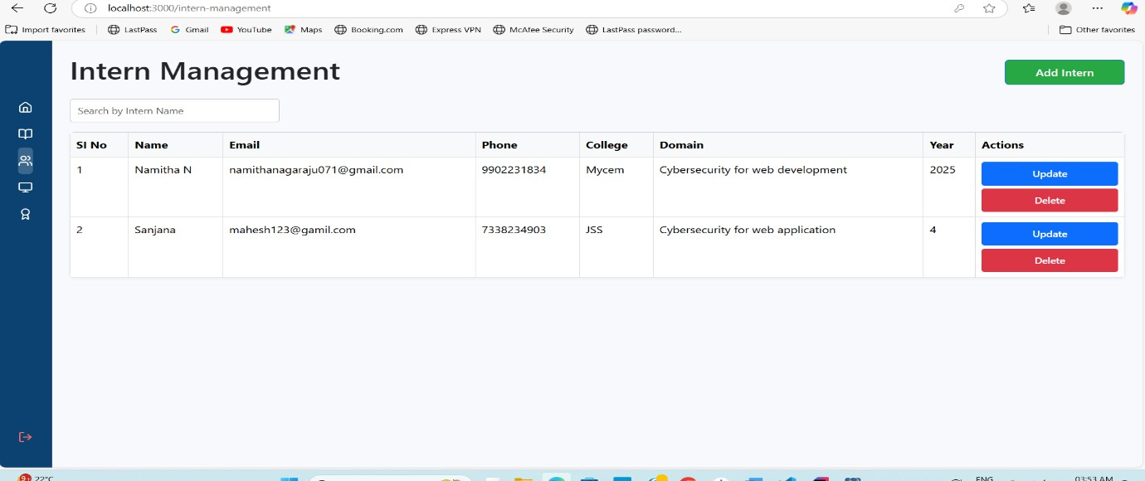
Fig 9.15: Intern Managemnt and Intern added by admin will display

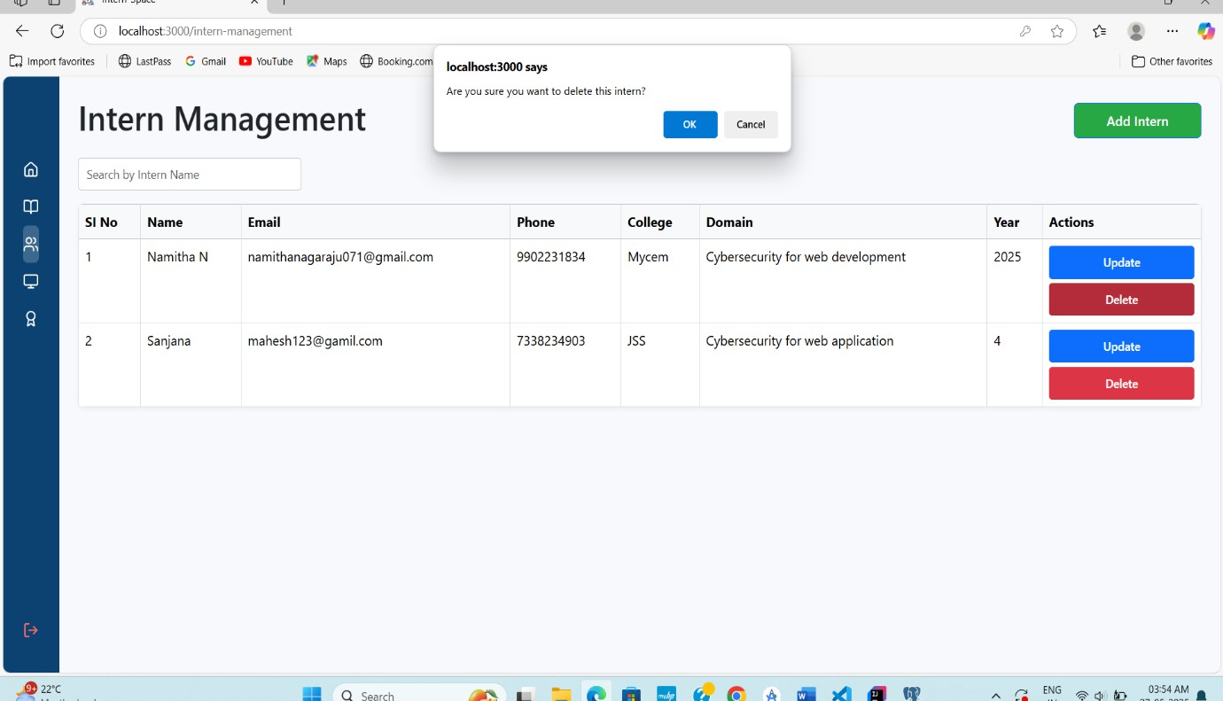
Fig 9.16 : Admin can update or Delete the Intern
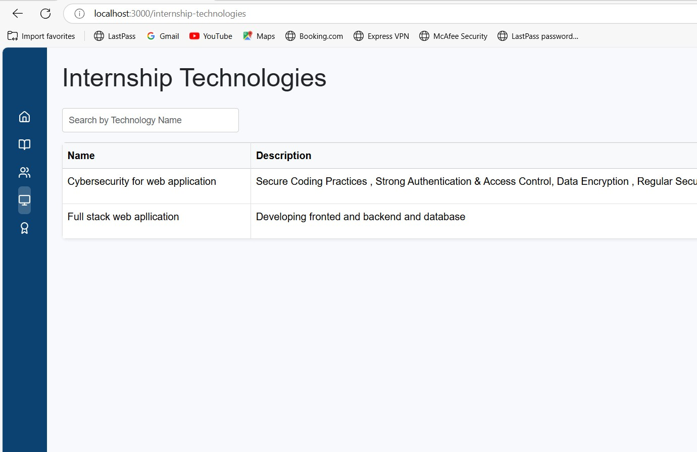

Fig 9.17: Internship Technologies

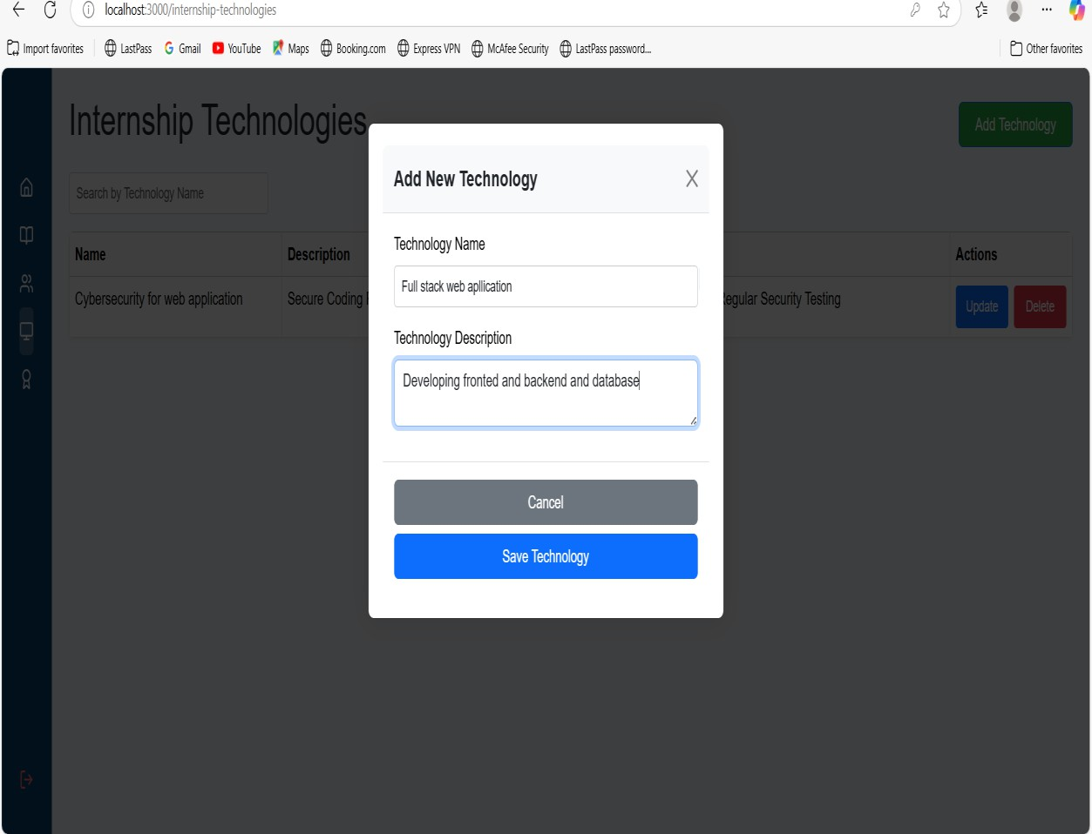
Fig 9.18 : New Technology can be add by Admin

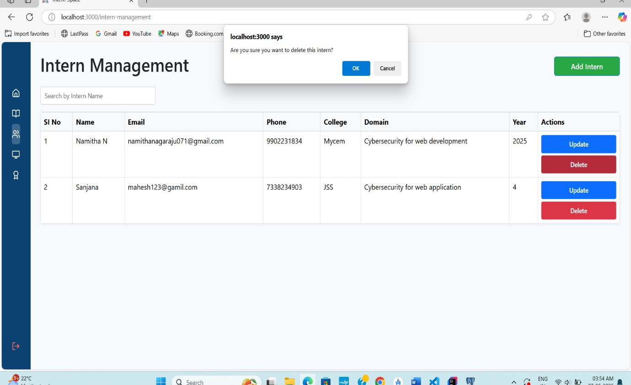
Fig 9.19: Admin can Update Or Delete Intern Management

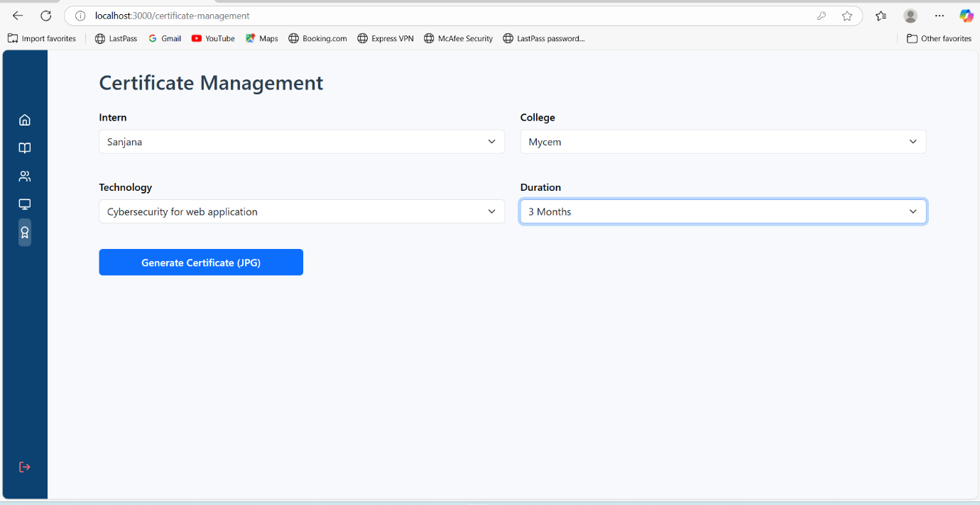
Fig 9.20 : Certificate Management

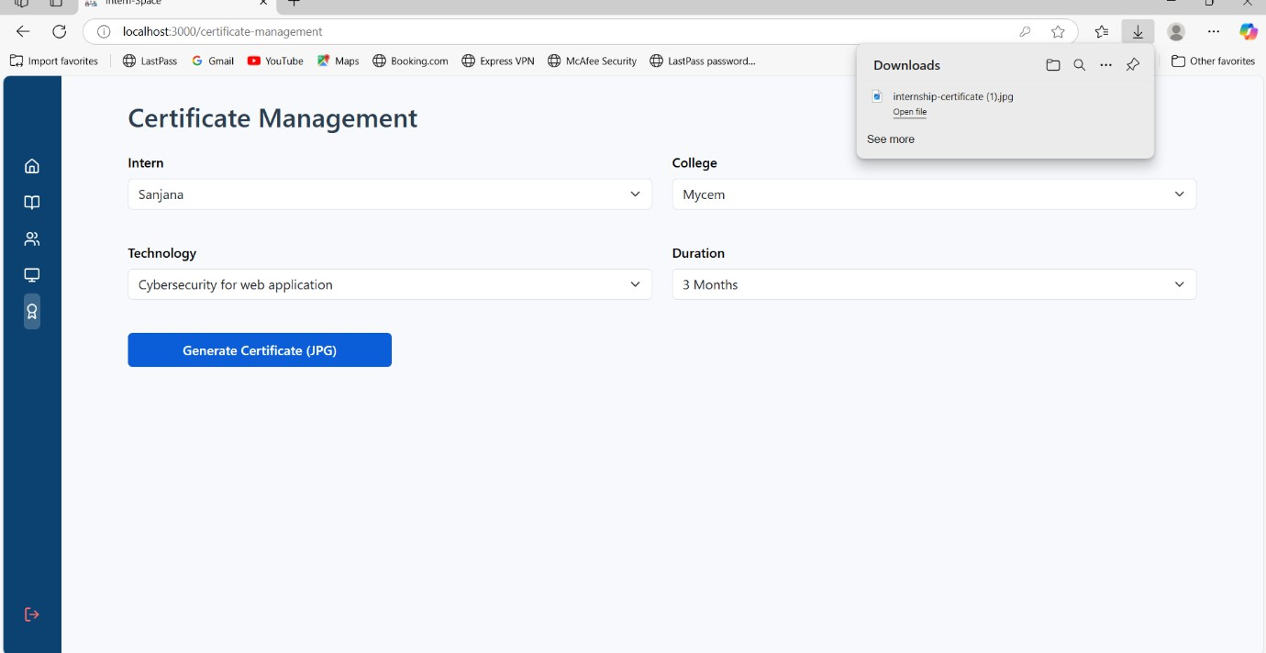

Fig 9.21 : Required credentials filled by an Admin and certificate is generated

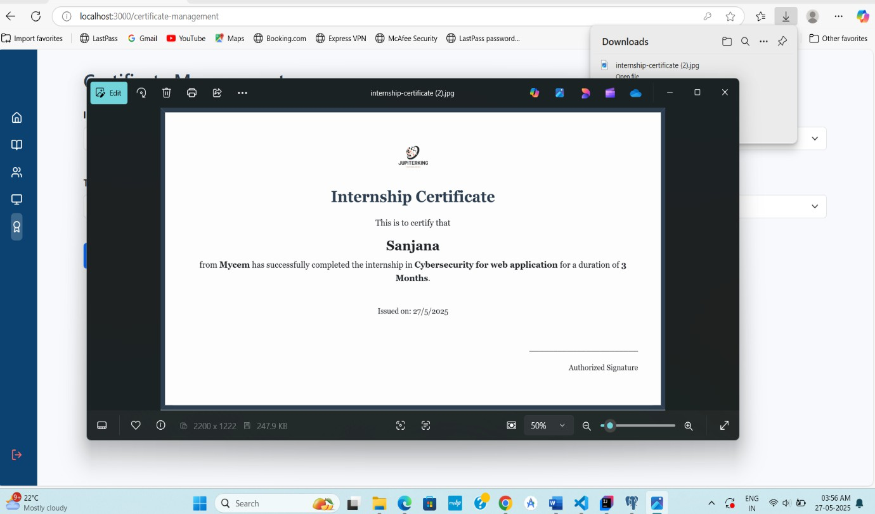
Fig 9.22 : Internship Certificate is generated

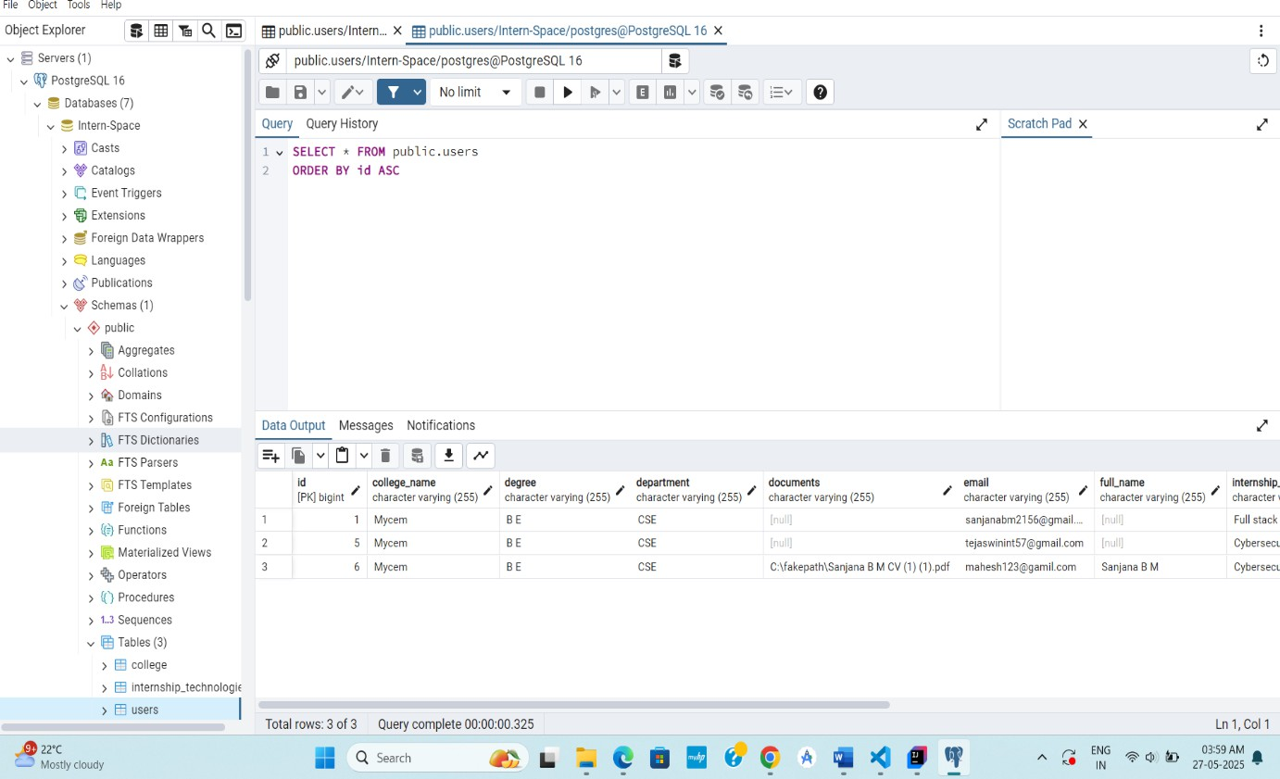
Fig 9.23 : Data is stored in backend and we can check that in pgAdmin

CONCLUSION
The JupiterKing Intern Space Project is a full-stack web application developed to simplify and automate the management of internship-related activities for educational institutions and organizations. Built using modern technologies such as React for the frontend, Spring Boot for backend RESTful APIs, and PostgreSQL (accessed through PgAdmin) for data storage, the application offers a seamless, scalable, and secure platform for administrators, interns, and college representatives.The project consists of several core modules that work in harmony to offer a complete internship management solution. The Dashboard module provides a centralized view of all key system statistics, allowing users to quickly access relevant information. The College Management module enables the addition and editing of college records, simplifying institutional data maintenance. The Intern Management module tracks intern details, including their enrollment, department, batch, and performance. The Internship Technologies module categorizes interns based on the technologies they are working on or learning during their internship period.

Lastly, the Certificate Management module automates the generation, assignment, and verification of internship certificates, reducing manual effort and human error.
Security is a critical component of this application. To ensure secure access and protect sensitive data, the system incorporates OTP-based login, which adds an extra layer of user verification via one-time passwords. In addition, the platform supports OAuth-based login, allowing users to securely authenticate using trusted third-party providers like Google, which minimizes the risk of password-related breaches and enhances the overall user experience.
The user interface, built using React, is highly responsive and user-friendly, offering a smooth navigation experience across different devices. The backend, powered by Spring Boot, ensures robust performance, efficient API handling, and seamless integration with the database.

In conclusion, the JupiterKing Intern Space Project successfully integrates advanced software development practices with essential cybersecurity features to deliver a reliable, efficient, and secure system for internship and academic institution management. It demonstrates the effective use of full-stack development technologies to solve real-world problems and serves as a valuable tool for educational institutions aiming to digitize their internship programs.

FUTURE SCOPE
The JupiterKing Intern Space Project has laid a strong foundation for managing internship processes digitally using a secure and scalable full-stack architecture. However, there are several promising areas where the system can be further expanded and enhanced to meet evolving user needs and technological advancements.One of the key future improvements lies in mobile application development. By building a cross-platform mobile app using frameworks such as React Native or Flutter, the system can provide interns and administrators with on-the- go access, push notifications, real-time updates, and a more personalized experience.

Another significant area of enhancement is the integration of AI-powered analytics and reporting. By incorporating machine learning algorithms, the platform could provide intelligent recommendations for interns based on their skills and interests, generate performance analytics, and offer insights into internship trends and participation rates.Additionally, the system could be extended to support automated resume generation, portfolio building, and project evaluation tools to help interns showcase their work and receive structured feedback. Integration with platforms such as LinkedIn could also be explored for seamless professional networking and certificate validation.

Coupled with advanced logging and monitoring systems, this would further strengthen the cybersecurity posture of the application.
The Certificate Management module can be enhanced with blockchain-based certificate validation, ensuring tamper-proof and verifiable credentials that can be trusted by employers and academic institutions alike. Finally, expanding the system to support multi-language localization and global institution partnerships can increase its reach and usability across different regions and academic

In conclusion, the JupiterKing Intern Space Project has the potential to evolve into a fully- featured internship ecosystem platform. With strategic future enhancements in mobility, AI, security, and scalability, it can significantly impact how institutions manage internships and how students gain valuable real-world experience.

INTERNSHIP OUTCOMES

SI NO | Weeks | Tasks
1 | First Week | - Learned basic web development using HTML and CSS  - Introduction to Angular framework for frontend development  - Setup development environment and explored project structure
2 | Second Week | - Installed and configured Visual Studio Code (VS Code)  - Initialized Angular project structure and created base components  - Designed and developed a basic Registration Page
3 | Third Week | - Implemented data binding techniques for form elements  - Applied two-way data binding using Angular’s ngModel  - Studied and implemented different types of Angular forms
4 | Fourth Week | - Learned and applied Angular directives (*ngIf,  *ngFor)  - Understood folder structure and workflow of Spring Boot  - Setup initial backend framework using Spring Boot CLI
5 | Fifth Week | - Initialized backend project using Spring Initializr  - Installed and configured Postman for API testing

 |  | 3) Created and tested initial sample REST APIs
6 | Sixth Week | - Developed backend APIs for registration and user management  - Handled HTTP methods and responses using Spring Boot  - Applied proper REST conventions and validation
7 | Seventh Week | - Connected Angular frontend to Spring Boot backend APIs  - Implemented service calls using HttpClient in Angular  - Handled API responses and form submissions
8 | Eighth Week | - Installed and configured pgAdmin with  PostgreSQL  - Integrated Spring Boot with PostgreSQL for data persistence  - Created database tables and tested CRUD operations
9 | Ninth Week | - Set up a new project using React for frontend  - Created registration components using ReactJS
10 | Tenth Week | - Connected React frontend with Spring Boot backend and database  - Tested data flow from frontend to database 3)Validated API request and response cycle using tools like Postman
11 | Eleventh Week | - Introduced to Cybersecurity principles for web applications  - Understood common vulnerabilities like XSS,

CSRF, SQL Injection
3) Applied secure coding practices in frontend and backend
12 | Twelfth Week | - Integrated OTP-based login functionality for authentication  - Created backend APIs to send and verify OTP codes  - Connected frontend forms with OTP logic and error handling
13 | Thirteenth Week | - Developed Forgot Password feature with OTP verification  - Validated user identity using registered email/mobile  - Allowed users to reset passwords securely
14 | Fourteenth Week | - Integrated OAuth 2.0 login using third-party providers  - Configured backend security with Spring Security OAuth  - Implemented secure login via Google OAuth on frontend
15 | Fifteenth Week | - Set up a Google Developer Account for OAuth credentials  - Generated Client ID and Secret for OAuth integration  - Successfully deployed and tested secure Google Login functionality

REFERENCES
- Angular Official Documentation https://angular.io/docs - Used for understanding Angular components, data binding, forms, directives, and HTTP client integration.
- Spring Boot Official Documentation – Spring Framework https://spring.io/projects/spring- boot – Referred to for backend API development, RESTful services, and security configurations.
- PostgreSQL Official Documentation https://www.postgresql.org/docs/ – Used for database setup, query optimization, and schema design.
- pgAdmin Official Documentation https://www.pgadmin.org/docs/ – Used for managing PostgreSQL databases and testing database operations.
- React Official Documentation https://reactjs.org/docs/getting-started.html – Used for understanding React components, state management, and form handling.
- OAuth 2.0 Authorization Framework – https://tools.ietf.org/html/rfc6749 – Referred to while implementing OAuth-based login for secure authentication.
- Google OAuth Integration Documentation https://developers.google.com/identity – Used to set up Google login and obtain OAuth credentials.
- Spring Security Official Documentation https://docs.spring.io/spring-security/ – Consulted for implementing security mechanisms like OTP and OAuth.
- Postman Learning Center https://learning.postman.com/ – Used for API testing and understanding request/response structures.

